AI & Deep Learning 2024 (Solution)

1. (20%) (Optimization)
2. (10%) Explain the SGD (Stochastic Gradient **Descent**) updating policy. You need to explain SGD in terms of the gradient of loss function 𝛻(𝐽(𝑤)), parameters (**w**), and the learning rateε. (10%). (Note that a ‘+’ or a ‘-‘ sign in the equation has a different meaning. Please don’t mix them up!)

$$w=w-ϵ∇(J\left(w\right))$$

The new weight (vector) equals the original weight minus Epsilon multiplied by the gradient of the loss function with weights as parameters.

1. Since simple SGD may be stuck in a local optimum or a saddle point, list at least two optimization algorithms that prevent the problems.

Adam, Adagrad

1. (20%)(Activation functions)

(a) (10%) Define the sigmoid activation function and derive its derivative. (導出它的微分公式)

$y=\frac{1}{1+e^{-z}}$

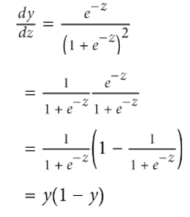

(b) (10%) The softmax activation function can be written as:

$F(x_{i})=\frac{e^{x_{i}}}{\sum_{j}{e^{x_{j}}}}$

(1) Where do we use a softmax function in a neural network?

It is used to transform the output of a neural net layer into a probability distribution.

(2) Derive the derivative of $F(x_{i})$, and show that it equals

$F(x_{i})$*(1- $F(x_{i})$)

Use the formula of (f*g)’=f’*g+f*g’)

$we have F{\left(x_{i}\right)}^{'}={\left(\frac{e^{x_{i}}}{\sum_{j}{e^{x_{j}}}}\right)}^{'}={\left(e^{x_{i}} \right)}^{'}*({\sum_{j}{e^{x_{j}})}}^{-1}+ e^{x_{i}}*(({\sum_{j}{e^{x_{j}})}}^{-1})'$

= $e^{x_{i}}*({\sum_{j}{e^{x_{j}})}}^{-1}-e^{x_{i}}*(\left({\sum_{j}{e^{x_{j}})}}^{-2}\right)*e^{x_{i}}=F\left(x_{i}\right)*(1-F\left(x_{i}\right))$

1. (20%) The following is a Keras code segment for a convolutional Neural network. The inputs are two-dimensional 32x32 CIFAR-10 color pictures. Answer the following questions:
2. (10%) What is the total number of parameters in **the first Conv2D layer**?

(5*5*3)*64 + 64 =

4864

1. (10%) What is **the output shape of the first Conv2D layer**?

dim=(32-5)/2 +1 =14, with 64 filters=>

(none, 14, 14, 64)

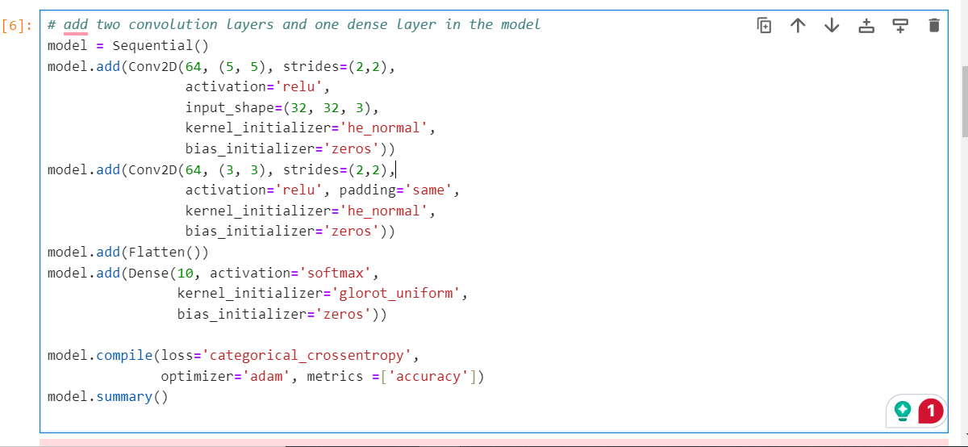

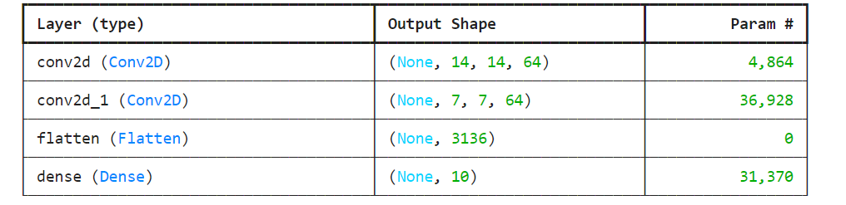

1. (Cross-Entropy) (20%) Calculate the cross-entropy of distribution P(X) on distribution Q(x) using the following equation:

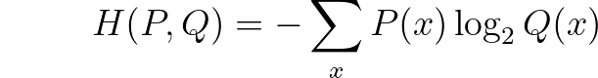

P(x)

Q(x)

Python code:

import numpy as np

P=[0.4, 0.2, 0.2, 0.2]

Q=[0.2, 0.2, 0.4, 0.2]

cross=0

for i in range(len(P)):

cross+=-(P[i]*np.log2(Q[i]))

print("Cross-entropy of P on Q is ", cross)

Ans. The cross-entropy of P on Q is 2.1219280948873624

1. (20%) (Gradient Descent) Suppose we want to fit an equation of two parameters for the following dataset:

x_data = [1.0, 2.0, 3.0, 4.0]

y_data = [3.0, 10.0, 21.0, 36.0] ,

where x_data contains the input values of x, and y_data contains the corresponding outputs.

The equation is $\hat{y}=x^{2}w_{2}+xw_{1}$

$w_{2},and w_{1}$ are parameters to be estimated. Furthermore, $w_{2},and w_{1}$ are initialized to 1 and 2, respectively. $That is w_{2 }=1 and w_{1}=2$. Answer the following questions with the loss function: $Loss={(\hat{y}-y)}^{2}$

(a) Find the gradient equations for w1 and w2, respectively.

Loss= =(2

2 * x * ((x**2 )* w2 +x*w1- y)

$\frac{∂ Loss}{∂w_{2}}=$ 2*(x**2)*((x**2 )* w2 +x*w1- y)

(b) Find the gradients of w1 and w2, respectively with the initial weights w2= 1 and w1 =2 for the first input x=1.0 and the output y=3.0.

(0, 0)

I will show the Python code in class to demonstrate the gradient exploding problem in SGD.